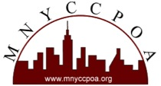

May 2, 2014
St. John’s University

AGENDA

Registration: 9-9:30am

Keynote: 9:30-10:30am
Tapping Your Inner Futurist: The Future of Work & Learning
Garry Golden will help us explore the future of work and career landscape.

Session One: 10:30-11am
Nate Graham: 20 Jobs of the Future
Nate Graham, Cultural Strategist at Sparks & Honey will discuss how emerging technologies and cultural shifts will impact the future of jobs.

Break: 11-11:15am

Session Two: 11:15am-12:15pm
Sabrina Woods: How are you Teaching LinkedIn?
Sabrina Woods will explore with you on what ways you are teaching LinkedIn and/or other social media topics at your organization

Lunch: 12:15-1:15pm

Business Meeting: 1:15-1:30pm

Alva Cooper Awards Presentations: 1:30-2:30pm

